**Lab 21: Android SQLite Database**

# **Introduction**

# For tasks like storing, altering, or retrieving persistent data from the database on Android devices, SQLite is an open-source relational database. It comes pre-installed on Android. Therefore, no database setup or management tasks are required. The ability to use the SQLite database is provided by the SQLiteOpenHelper class.

**Let’s get Started:**

In this experiment we will develop an Android App to demonstrate the use of Android SQLite Database.

* Launching File Explorer
* access the data directory
* Look up the name of your application package in the data directory.
* Go to databases in your application package to access your database (contactsManager)
* A copy of your database can be saved.
* any tool or browser extension for SQLite. DB Browser for SQLite, for instance
* Open your database in the programme (DB Browser for SQLite) by launching it.
* You can then choose and view the data in your database depending on the tool you're using.
* To see the stored data, for instance, pick your table (contacts) from the Browse Data menu in the DB Browser for SQLite.

**Download & Install**

* [DB Browser for SQLite - Standard installer for 64-bit Windows](https://download.sqlitebrowser.org/DB.Browser.for.SQLite-3.12.2-win64.msi)

**Step 1: Create a New Project in Android Studio as shown below**

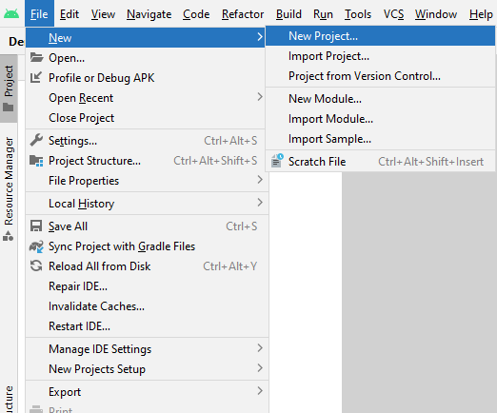

**Step 2: Select Empty Activity as shown below**

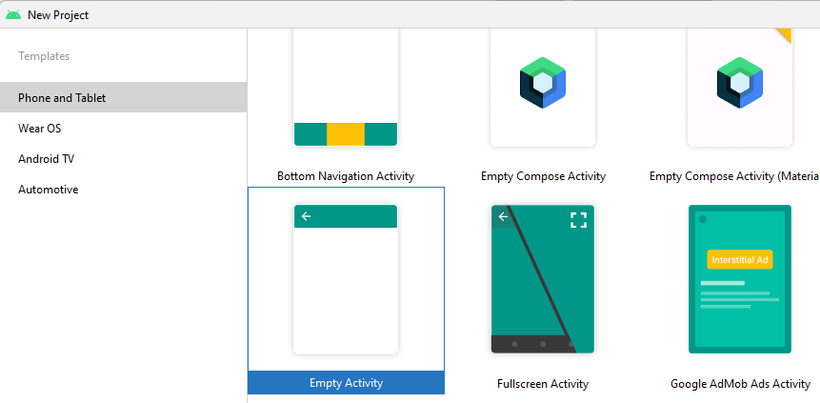

**Step 3: Provide a Project Name as shown below**

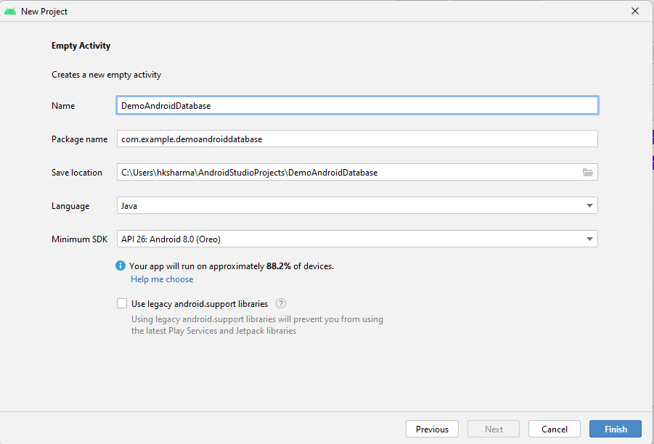

**Step 4: Update MainActivity.kt as per the code given below**

**package** com.example.demokotlindb  
**import** androidx.appcompat.app.AppCompatActivity  
**import** android.os.Bundle  
**import** android.widget.Toast  
**import** kotlinx.android.synthetic.main.activity_main.*  
  
**class** MainActivity : AppCompatActivity() {  
 **override fun** onCreate(savedInstanceState: Bundle?) {  
 **super**.onCreate(savedInstanceState)  
 setContentView(R.layout.*activity_main*)  
 addName.setOnClickListener**{  
 val** db = DBHelper(**this**, **null**)  
 **val** name = enterName.*text*.toString()  
 **val** age = enterAge.*text*.toString()  
 db.addName(name, age)  
 Toast.makeText(**this**, name + **" added to database"**, Toast.*LENGTH_LONG*).show()  
 enterName.*text*.clear()  
 enterAge.*text*.clear()  
 **}** printName.setOnClickListener**{  
 val** db = DBHelper(**this**, **null**)  
 **val** cursor = db.getName()  
 cursor!!.moveToFirst()  
 Name.append(cursor.getString(cursor.getColumnIndex(DBHelper.**NAME_COl**)) + **"\n"**)  
 Age.append(cursor.getString(cursor.getColumnIndex(DBHelper.**AGE_COL**)) + **"\n"**)  
  
 **while**(cursor.moveToNext()){  
 Name.append(cursor.getString(cursor.getColumnIndex(DBHelper.**NAME_COl**)) + **"\n"**)  
 Age.append(cursor.getString(cursor.getColumnIndex(DBHelper.**AGE_COL**)) + **"\n"**)  
 }  
 cursor.close()  
 **}** }  
}

}

**Step 5: Create DBHandler.kt as per the code given below**

**package** com.example.demokotlindb  
**import** android.content.ContentValues  
**import** android.content.Context  
**import** android.database.Cursor  
**import** android.database.sqlite.SQLiteDatabase  
**import** android.database.sqlite.SQLiteOpenHelper  
  
**class** DBHelper(context: Context, factory: SQLiteDatabase.CursorFactory?) :  
 SQLiteOpenHelper(context, **DATABASE_NAME**, factory, **DATABASE_VERSION**)

{  
  
 **override fun** onCreate(db: SQLiteDatabase) {  
 **val** query = (**"CREATE TABLE "** + **TABLE_NAME** + **" ("** + **ID_COL** + **" INTEGER PRIMARY KEY, "** +  
 **NAME_COl** + **" TEXT,"** +  
 **AGE_COL** + **" TEXT"** + **")"**)  
 db.execSQL(query)  
 }  
  
 **override fun** onUpgrade(db: SQLiteDatabase, p1: Int, p2: Int) {  
 db.execSQL(**"DROP TABLE IF EXISTS "** + **TABLE_NAME**)  
 onCreate(db)  
 }  
 **fun** addName(name : String, age : String ){  
 **val** values = ContentValues()  
 values.put(**NAME_COl**, name)  
 values.put(**AGE_COL**, age)  
 **val** db = **this**.*writableDatabase* db.insert(**TABLE_NAME**, **null**, values)  
 db.close()  
 }  
 **fun** getName(): Cursor? {  
 **val** db = **this**.*readableDatabase* **return** db.rawQuery(**"SELECT * FROM "** + **TABLE_NAME**, **null**)  
  
 }  
  
 **companion object**{  
 **private val DATABASE_NAME** = **"snap"  
 private val DATABASE_VERSION** = 1  
 **val TABLE_NAME** = **"snap_table"  
 val ID_COL** = **"id"  
 val NAME_COl** = **"name"  
 val AGE_COL** = **"age"** }  
}

**Step 6: Update activity_main.xml for Relative Layout as per the code given below**

*<?xml version="1.0" encoding="utf-8"?>*

*<LinearLayout*

*xmlns:android="http://schemas.android.com/apk/res/android"*

*xmlns:app="http://schemas.android.com/apk/res-auto"*

*xmlns:tools="http://schemas.android.com/tools"*

*android:layout_width="match_parent"*

*android:layout_height="match_parent"*

*android:orientation="vertical"*

*tools:context=".MainActivity">*

*<!-- Edit text to enter name -->*

*<EditText*

*android:id="@+id/enterName"*

*android:layout_width="match_parent"*

*android:layout_height="wrap_content"*

*android:hint="Enter Name"*

*android:textSize="22sp"*

*android:layout_margin="20sp"/>*

*<!-- Edit text to enter age -->*

*<EditText*

*android:id="@+id/enterAge"*

*android:layout_width="match_parent"*

*android:layout_height="wrap_content"*

*android:layout_margin="20sp"*

*android:textSize="22sp"*

*android:hint="Enter Age"/>*

*<!-- Button to add Name -->*

*<Button*

*android:id="@+id/addName"*

*android:layout_width="150sp"*

*android:layout_gravity="center"*

*android:background="@color/colorPrimary"*

*android:text="Add Name"*

*android:textColor="#ffffff"*

*android:textSize="20sp"*

*android:layout_height="wrap_content"*

*android:layout_marginTop="20sp"/>*

*<!-- Button to print Name -->*

*<Button*

*android:id="@+id/printName"*

*android:layout_width="150sp"*

*android:layout_gravity="center"*

*android:background="@color/colorPrimary"*

*android:text="Print Name"*

*android:textColor="#ffffff"*

*android:textSize="20sp"*

*android:layout_height="wrap_content"*

*android:layout_marginTop="20sp"/>*

*<LinearLayout*

*android:layout_width="match_parent"*

*android:layout_height="wrap_content">*

*<!-- Text view to get all name -->*

*<TextView*

*android:id="@+id/Name"*

*android:textAlignment="center"*

*android:layout_weight="1"*

*android:layout_width="match_parent"*

*android:layout_height="wrap_content"*

*android:layout_margin="20sp"*

*android:text="Name\n\n"*

*android:textSize="22sp"*

*android:padding="10sp"*

*android:textColor="#000000"/>*

*<!-- Text view to get all ages -->*

*<TextView*

*android:layout_weight="1"*

*android:id="@+id/Age"*

*android:textAlignment="center"*

*android:layout_width="match_parent"*

*android:layout_height="wrap_content"*

*android:layout_margin="20sp"*

*android:text="Age\n\n"*

*android:textSize="22sp"*

*android:padding="10sp"*

*android:textColor="#000000"/>*

*</LinearLayout>*

*</LinearLayout>*

**Step 7: Update AndroidManifest.xml for as per the code given below**

*<?***xml version="1.0" encoding="utf-8"***?>*<**manifest xmlns:android="http://schemas.android.com/apk/res/android"  
 xmlns:tools="http://schemas.android.com/tools"**>  
 <**uses-permission android:name="android.permission.READ_EXTERNAL_STORAGE"** />  
  
 <**application  
 android:allowBackup="true"  
 android:dataExtractionRules="@xml/data_extraction_rules"  
 android:fullBackupContent="@xml/backup_rules"  
 android:icon="@mipmap/ic_launcher"  
 android:label="@string/app_name"  
 android:roundIcon="@mipmap/ic_launcher_round"  
 android:supportsRtl="true"  
 android:theme="@style/Theme.DemoKotlinDB"  
 tools:targetApi="31"**>  
 <**activity  
 android:name=".MainActivity"  
 android:exported="true"**>  
 <**intent-filter**>  
 <**action android:name="android.intent.action.MAIN"** />  
  
 <**category android:name="android.intent.category.LAUNCHER"** />  
 </**intent-filter**>  
  
 <**meta-data  
 android:name="android.app.lib_name"  
 android:value=""** />  
 </**activity**>  
 </**application**>  
  
</**manifest**>

**Step 8: Check Output on Android Emulator and it should look like as given below**

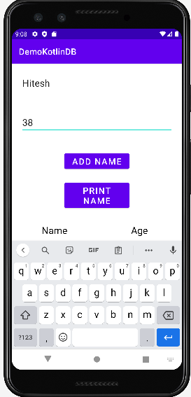 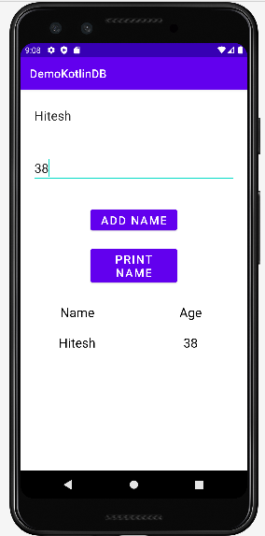

**Step 9: Check Database as given below**

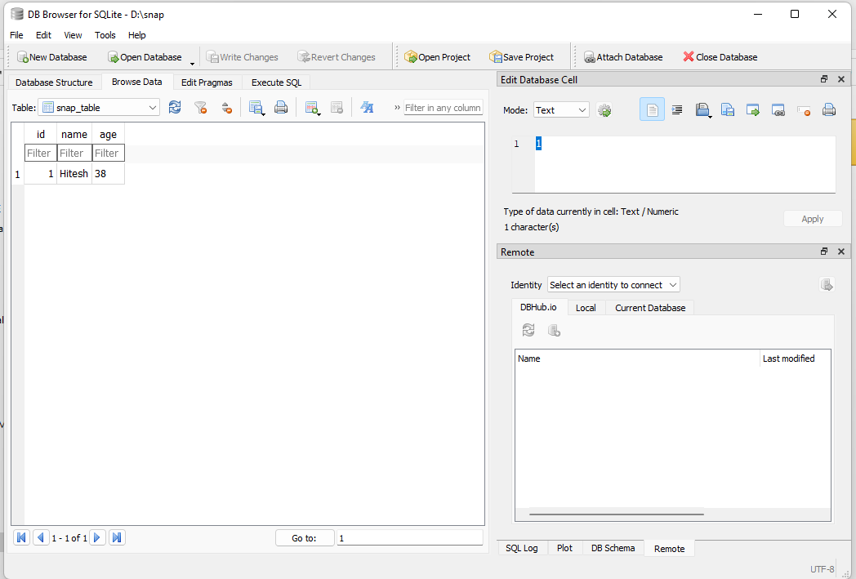

**Voila!!** We have successfully completed this lab.